SACCO MANAGEMENT SYSTEM
Mobile App Capstone Project — System Analysis & Design Document

Problem Statement
Target Audience: Members of Savings and Credit Co-operative Organizations (SACCOs), SACCO administrators, and loan officers.

The Core Problem: Many traditional SACCOs rely heavily on manual record-keeping, paper passbooks, and delayed cash or bank transfers. This operational friction results in human calculation errors, a lack of real-time visibility into savings balances, lengthy loan review workflows, and overall opacity in financial tracking. Members frequently struggle to monitor their savings growth, verify loan repayment schedules, or apply for emergency funds without physically visiting SACCO branch offices.

How the App Helps: The Sacco Management System mobile application modernizes and streamlines cooperative financial management. It digitizes member onboarding, tracks share capital and savings deposits in real-time, automates loan scoring and approval workflows, processes secure digital repayments, and delivers transparent, downloadable financial statements directly to members' smartphones.

Users and Their Goals
SACCO Member: Wants to view real-time savings and share balances, apply for micro-loans, track loan approval statuses, monitor repayment schedules, and review complete transaction histories. Loan Officer / Administrator: Wants to review pending loan applications, evaluate eligibility against automated savings multipliers, approve or reject loans with audit notes, disburse funds, and oversee member accounts.
System Super Administrator: Wants to manage user role hierarchies, configure global system parameters (such as interest rates and maximum loan multipliers), audit system logs, and ensure database integrity.

System Requirements
Functional Requirements (The system shall...)
Allow new users to register and authenticate securely using mobile number/email and encrypted passwords.
Allow members to deposit funds into their savings or share capital accounts via integrated payment gateways.
Allow members to submit structured loan applications specifying requested amount, repayment period, and purpose.
Automatically calculate maximum allowable loan limits based on a member's total verified savings balance (e.g., 3x savings multiplier rule).
Allow loan officers to review pending loan applications and update their status to Approved or Rejected with feedback comments.
Enable members to view real-time account balances, segregated by savings, shares, and active loan liabilities.
Generate detailed, itemized transaction history statements for any selected custom date range. Send push notifications and SMS alerts to members upon successful deposits, loan approvals, disbursements, and payment due reminders.
Allow administrators to manage user profiles, activate/deactivate accounts, and configure systemwide loan interest rates.
Provide an automated monthly interest calculation and posting mechanism for member savings accounts.

Non-Functional Requirements
Performance & Usability: The mobile application must remain fully responsive and functional even on constrained or intermittent mobile network connections (2G/3G environments).
Security: All user credentials and financial transactions must be strictly encrypted in transit (HTTPS/ TLS 1.3) and at rest (bcrypt password hashing, AES database encryption).
Availability & Reliability: The backend API and database architecture must maintain 99.9% uptime during operational business hours with automated daily backups.

User Stories
US-01: As a member, I want to log in securely with my credentials so that my personal financial data remains private and protected.
US-02: As a member, I want to view my current savings and share capital balances on the home dashboard so I know my current financial standing.
US-03: As a member, I want to apply for a micro-loan directly from my phone so that I do not need to visit the office physically.
US-04: As a member, I want to view my active loan repayment schedule so I can make timely payments and avoid late penalties.
US-05: As a member, I want to download my complete transaction statement as a PDF for personal record-keeping and auditing.
US-06: As a loan officer, I want to view a list of all pending loan applications sorted by submission date so I can process them efficiently.
US-07: As a loan officer, I want to approve or reject a loan application with a comment field so members understand the decision rationale.
US-08: As an administrator, I want to configure the global interest rate for loans so that the SACCO's financial policies are correctly enforced.

Entity Relationship Diagram (ERD) Overview

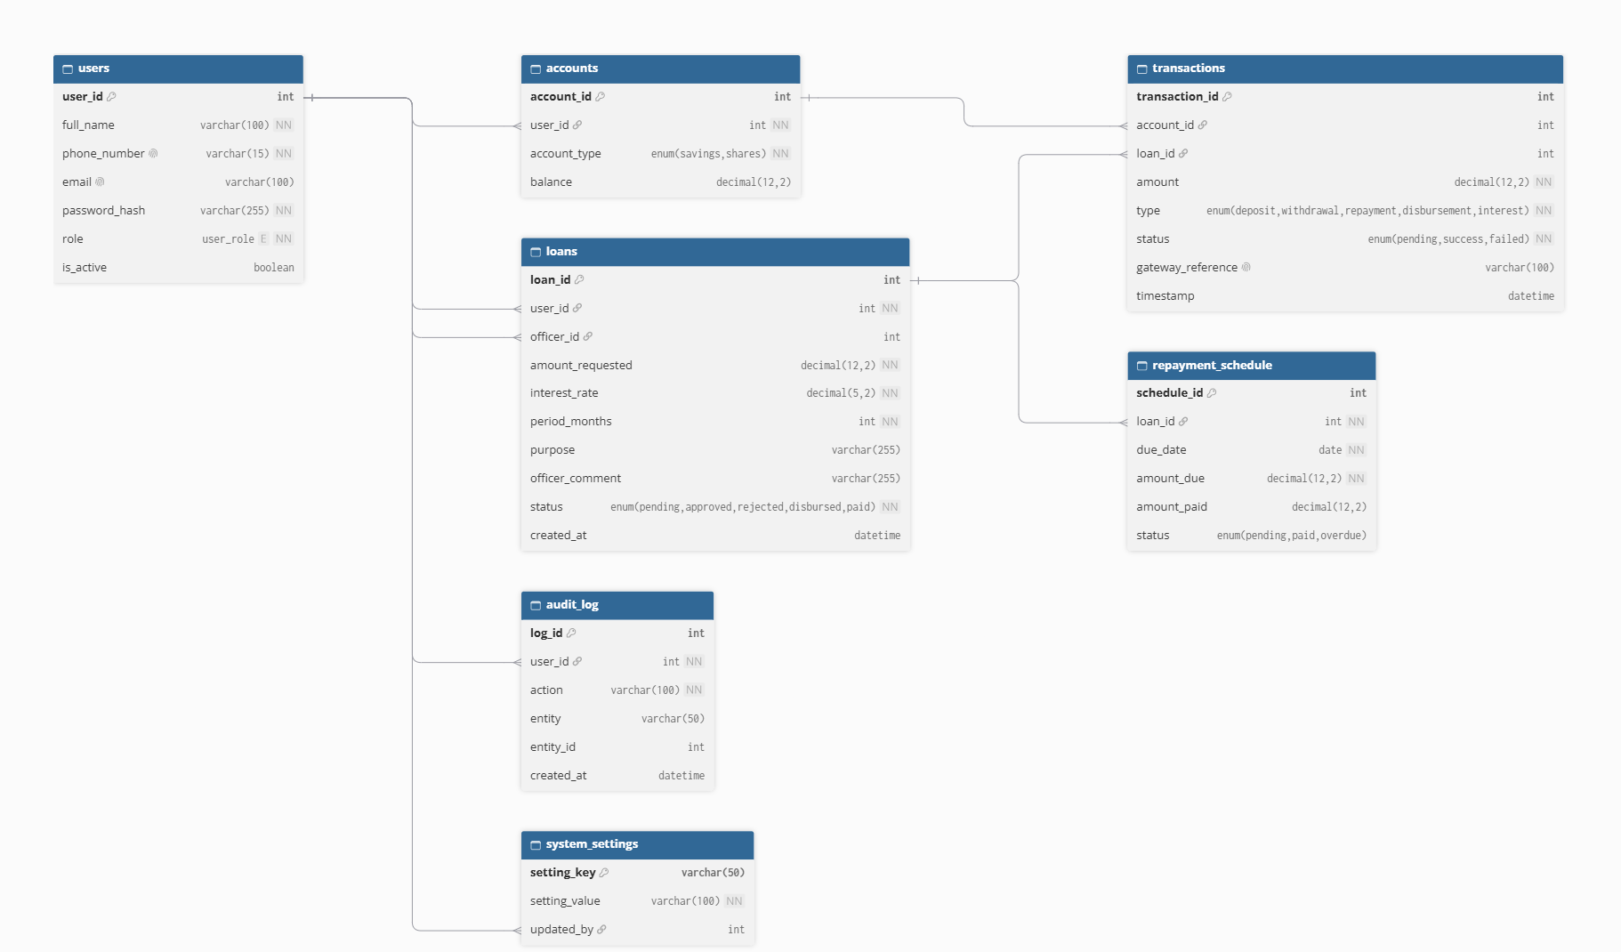Core Relational Mapping
- User (1) to Account (N): A single user can own multiple financial accounts (e.g., separate balances for Savings and Shares).
- User (1) to Loan (Borrower) (N): A user can submit multiple loan applications over their operational lifecycle.
- User (1) to Loan (Officer) (N): A user with the loan_officer role can be assigned to manage and review multiple loan facilities.
- Account (1) to Transaction (N): Monetary transactions (deposits, withdrawals) are directly linked to an account.
- Loan (1) to Transaction (N): Loan-related ledger activities (disbursements, repayments) reference the specific loan facility.
- Loan (1) to Repayment Schedule (N): Each active loan generates a deterministic series of installment obligations over time.
- User (1) to Audit Log (N): System user activity is logged to trace actions back to the initiating user account.
- User (1) to System Settings (N): Administrative users maintain global operational key-value pairs.

Data Dictionary

Entity: users
Stores user account identities, security credentials, contact details, and role privilege levels.

Column Name | Data Type | Constraints | Description
user_id | INT | PK, Auto Increment | Unique system identifier for the user
full_name | VARCHAR(100) | NOT NULL | Full legal name of the user
phone_number | VARCHAR(15) | UNIQUE, NOT NULL | Primary mobile number used for authentication & notifications
email | VARCHAR(100) | NULL | Primary email address for electronic statements
password_hash | VARCHAR(255) | NOT NULL | Securely hashed password (Bcrypt)
role | ENUM | NOT NULL | Permission tier: 'member', 'loan_officer', 'admin', 'super_admin'
is_active | BOOLEAN | DEFAULT TRUE | Indicates if the user account is active

Entity: accounts
Maintains ledger balances for individual member accounts separated by account classification.

Column Name | Data Type | Constraints | Description
account_id | INT | PK, Auto Increment | Unique account identifier
user_id | INT | FK to users.user_id, NOT NULL | Foreign key mapping to account owner
account_type | ENUM | NOT NULL | Nature of funds: 'savings', 'shares'
balance | DECIMAL(12,2) | DEFAULT 0.00 | Current available monetary balance

Entity: loans
Tracks loan applications, approvals, terms, assigned staff, and overall lifecycle states.

Column Name | Data Type | Constraints | Description
loan_id | INT | PK, Auto Increment | Unique loan facility identifier
user_id | INT | FK to users.user_id, NOT NULL | Foreign key referencing the primary borrower
officer_id | INT | FK to users.user_id, NULL | Foreign key referencing assigned loan officer
amount_requested | DECIMAL(12,2) | NOT NULL | Principal loan amount requested
interest_rate | DECIMAL(5,2) | NOT NULL | Annualized interest percentage rate
period_months | INT | NOT NULL | Agreed repayment duration in months
purpose | VARCHAR(255) | NULL | Purpose statement for the loan request
officer_comment | VARCHAR(255) | NULL | Formal underwriting or review notes
status | ENUM | NOT NULL | Lifecycle state: 'pending', 'approved', 'rejected', 'disbursed', 'paid'
created_at | DATETIME | DEFAULT CURRENT_TIMESTAMP | Timestamp when application was created

Entity: transactions
Records all monetary ledger movements, payment state processing, and gateway references.

Column Name | Data Type | Constraints | Description
transaction_id | INT | PK, Auto Increment | Unique financial transaction record ID
account_id | INT | FK to accounts.account_id, NULL | Referenced account (if account action)
loan_id | INT | FK to loans.loan_id, NULL | Referenced loan facility (if loan action)
amount | DECIMAL(12,2) | NOT NULL | Transaction value
type | ENUM | NOT NULL | Classification: 'deposit', 'withdrawal', 'repayment', 'disbursement', 'interest'
status | ENUM | NOT NULL | State: 'pending', 'success', 'failed'
gateway_reference | VARCHAR(100) | NULL | Unique transaction ID from external payment gateway
timestamp | DATETIME | DEFAULT CURRENT_TIMESTAMP | Exact execution timestamp

Entity: repayment_schedule
Defines installment obligation dates, expected amounts, and settlement tracking for active loans.

Column Name | Data Type | Constraints | Description
schedule_id | INT | PK, Auto Increment | Unique schedule line item ID
loan_id | INT | FK to loans.loan_id, NOT NULL | Parent loan reference
due_date | DATE | NOT NULL | Payment deadline date
amount_due | DECIMAL(12,2) | NOT NULL | Scheduled payment amount due
amount_paid | DECIMAL(12,2) | DEFAULT 0.00 | Sum of payments applied toward installment
status | ENUM | DEFAULT 'pending' | Installment state: 'pending', 'paid', 'overdue'

Entity: audit_log
Captures action traces for security reviews, compliance reporting, and systemic changes.

Column Name | Data Type | Constraints | Description
log_id | INT | PK, Auto Increment | Unique log entry primary key
user_id | INT | FK to users.user_id, NOT NULL | Actor who initiated the system action
action | VARCHAR(100) | NOT NULL | Human-readable descriptor of action taken
entity | VARCHAR(50) | NULL | Target schema table modified (e.g., 'loans')
entity_id | INT | NULL | Target primary key ID modified
created_at | DATETIME | DEFAULT CURRENT_TIMESTAMP | Log generation timestamp

Entity: system_settings
Stores global platform defaults, business logic limits, and configuration values.

Column Name | Data Type | Constraints | Description
setting_key | VARCHAR(50) | PK | Unique string identifier key for parameter
setting_value | VARCHAR(100) | NOT NULL | Parameter value string
updated_by | INT | FK to users.user_id, NULL | Admin who last altered configuration

API Endpoint Table
